Oblique Quadrilateral Prism
# Source: AI Source: Provided by: [Data Path: Persons Table -> ID Column: 1, Name_En Column: Motasem Essam] -> From: [ChatGPT] on [7/25/2026]
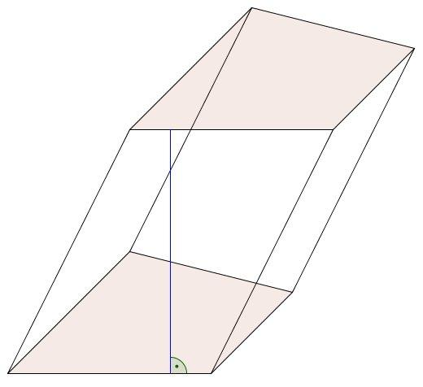
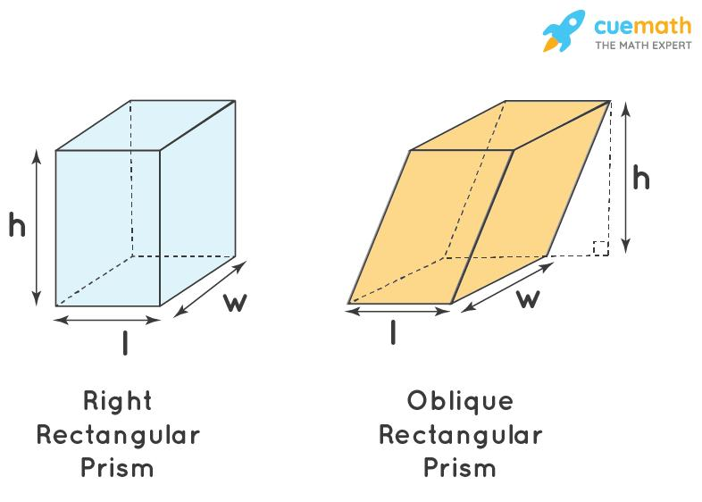
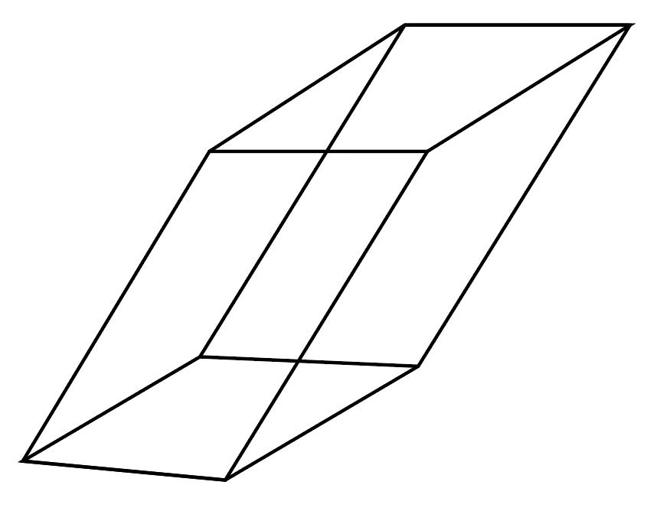

Definition
# Source: AI Source: Provided by: [Data Path: Persons Table -> ID Column: 1, Name_En Column: Motasem Essam] -> From: [ChatGPT] on [7/25/2026]
An oblique quadrilateral prism is a three-dimensional polyhedron with two congruent, parallel quadrilateral bases and lateral edges that are inclined to the base planes rather than perpendicular to them.
Because the lateral edges are inclined, the four lateral faces are parallelograms. The bases remain congruent and parallel, as required for every prism.
An oblique quadrilateral prism has:
- 2 congruent, parallel quadrilateral bases.
- 4 parallelogram-shaped lateral faces.
- 6 faces in total.
- 12 edges.
- 8 vertices.
The defining feature is its spatial orientation, not the shape of its quadrilateral bases.

Simple Definition
# Source: AI Source: Provided by: [Data Path: Persons Table -> ID Column: 1, Name_En Column: Motasem Essam] -> From: [ChatGPT] on [7/25/2026]
An oblique quadrilateral prism is a 3D solid with two matching four-sided bases connected by slanted side edges.
Unlike a right quadrilateral prism, its lateral edges do not meet the base planes at right angles.

Key Characteristics
# Source: AI Source: Provided by: [Data Path: Persons Table -> ID Column: 1, Name_En Column: Motasem Essam] -> From: [ChatGPT] on [7/25/2026]
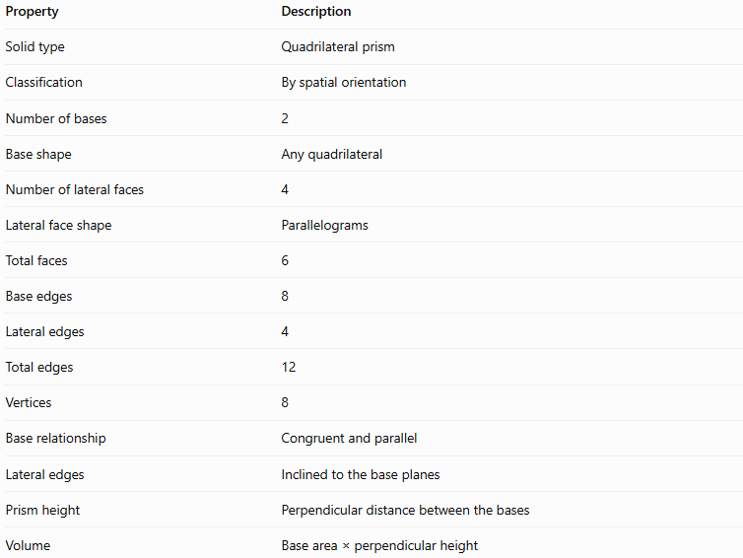
Property | Description
Solid type | Quadrilateral prism
Classification | By spatial orientation
Number of bases | 2
Base shape | Any quadrilateral
Number of lateral faces | 4
Lateral face shape | Parallelograms
Total faces | 6
Base edges | 8
Lateral edges | 4
Total edges | 12
Vertices | 8
Base relationship | Congruent and parallel
Lateral edges | Inclined to the base planes
Prism height | Perpendicular distance between the bases
Volume | Base area × perpendicular height

Geometric Representation
# Source: AI Source: Provided by: [Data Path: Persons Table -> ID Column: 1, Name_En Column: Motasem Essam] -> From: [ChatGPT] on [7/25/2026]
The principal components are:
- Base faces: Two congruent, parallel quadrilaterals.
- Lateral faces: Four parallelograms connecting corresponding base edges.
- Base edges: Four edges on each base, giving eight in total.
- Lateral edges: Four slanted edges connecting corresponding vertices.
- Vertices: Eight corner points.
- Height: The perpendicular distance between the base planes, not the length of a slanted lateral edge.
The inclination makes the prism appear to lean to one side, but its two bases remain parallel and identical in shape and size.

Mathematical Representations and Formulas
# Source: AI Source: Provided by: [Data Path: Persons Table -> ID Column: 1, Name_En Column: Motasem Essam] -> From: [ChatGPT] on [7/25/2026]
Let:
- $B$ = area of one quadrilateral base.
- $p$ = perimeter of the base.
- $h$ = perpendicular height of the prism.
- $L$ = length of a lateral edge.
- $α$ = angle between a lateral edge and the base plane.
- $A_{L}$ = lateral surface area.
- $A_{T}$ = total surface area.
- $V$ = volume.

A. Number of faces, edges, and vertices
# Source: AI Source: Provided by: [Data Path: Persons Table -> ID Column: 1, Name_En Column: Motasem Essam] -> From: [ChatGPT] on [7/25/2026]
For an $n$-gonal prism:
$$F=n+2, E=3n, V=2n$$
For a quadrilateral prism, $n=4$:
$$F=4+2=6$$
$$E=3\left(4\right)=12$$
$$V=2\left(4\right)=8$$

B. Volume
# Source: AI Source: Provided by: [Data Path: Persons Table -> ID Column: 1, Name_En Column: Motasem Essam] -> From: [ChatGPT] on [7/25/2026]
The volume of an oblique prism is the base area multiplied by the perpendicular distance between its bases:
$$\boxed{V=Bh}$$
This is the same volume formula used for a right prism.
Important: Use the perpendicular height, not the slanted lateral edge length.

C. Relationship between height and lateral edge length
# Source: AI Source: Provided by: [Data Path: Persons Table -> ID Column: 1, Name_En Column: Motasem Essam] -> From: [ChatGPT] on [7/25/2026]
For a lateral edge of length $L$ making an angle $α$ with the base plane:
$$\boxed{h=L\sin{α}}$$
This relationship applies when $α$ is measured as the acute angle between the lateral edge and the base plane.
Consequently:
$$L=\frac{h}{\sin{α}}$$
Since the lateral edges are inclined rather than perpendicular, $L$ is generally greater than $h$.

D. Lateral surface area
# Source: AI Source: Provided by: [Data Path: Persons Table -> ID Column: 1, Name_En Column: Motasem Essam] -> From: [ChatGPT] on [7/25/2026]
For an oblique prism, the lateral surface area is the sum of the areas of its four parallelogram-shaped lateral faces:
$$\boxed{A_{L}=A_{1}+A_{2}+A_{3}+A_{4}}$$
For each lateral face:
$$A_{i}=\left(\text{base-edge length}\right)\left(\text{perpendicular face altitude}\right)$$
In general, the lateral surface area cannot be calculated as $ph$, because $h$ is perpendicular to the base planes and is not necessarily the altitude of any lateral face.

E. Total surface area
# Source: AI Source: Provided by: [Data Path: Persons Table -> ID Column: 1, Name_En Column: Motasem Essam] -> From: [ChatGPT] on [7/25/2026]
The total surface area includes the four lateral faces and both bases:
$$\boxed{A_{T}=A_{L}+2B}$$
The base area $B$ is calculated using the appropriate formula for the quadrilateral.

F. Euler’s formula
# Source: AI Source: Provided by: [Data Path: Persons Table -> ID Column: 1, Name_En Column: Motasem Essam] -> From: [ChatGPT] on [7/25/2026]
For a convex polyhedron:
$$V-E+F=2$$
For an oblique quadrilateral prism:
$$8-12+6=2$$
Thus, Euler’s formula is satisfied.

Worked Examples
# Source: AI Source: Provided by: [Data Path: Persons Table -> ID Column: 1, Name_En Column: Motasem Essam] -> From: [ChatGPT] on [7/25/2026]
Example 1: Counting faces, edges, and vertices
Problem: Find the number of faces, edges, and vertices of an oblique quadrilateral prism.
A quadrilateral has four sides, so $n=4$.
$$F=n+2=6$$
$$E=3n=12$$
$$V=2n=8$$
Answer: 6 faces, 12 edges, and 8 vertices.
Example 2: Calculating the volume
Problem: An oblique quadrilateral prism has a base area of $36{\text{ cm}}^{2}$ and a perpendicular height of $10\text{ cm}$. Find its volume.
Using:
$$V=Bh$$
Substitute the values:
$$V=36\left(10\right)$$
$$\boxed{V=360{\text{ cm}}^{3}}$$
The slant of the prism does not change the volume when the base area and perpendicular height remain the same.
Example 3: Finding the perpendicular height
Problem: A lateral edge is $13\text{ cm}$ long and makes an angle of approximately ${67.38}^{∘}$ with the base plane. Find the prism height.
Using:
$$h=L\sin{α}$$
$$h=13{\sin{67.38}}^{∘}$$
Since ${\sin{67.38}}^{∘}≈0.9231$:
$$h≈13\left(0.9231\right)$$
$$\boxed{h≈12\text{ cm}}$$
Example 4: Calculating lateral and total surface area
Problem: An oblique quadrilateral prism has a base area of $24{\text{ cm}}^{2}$. Its four lateral faces have areas of $30{\text{ cm}}^{2}$, $36{\text{ cm}}^{2}$, $30{\text{ cm}}^{2}$, and $36{\text{ cm}}^{2}$. Find its lateral and total surface areas.
Step 1: Add the four lateral face areas.
$$A_{L}=30+36+30+36$$
$$\boxed{A_{L}=132{\text{ cm}}^{2}}$$
Step 2: Add the two bases.
$$A_{T}=A_{L}+2B$$
$$A_{T}=132+2\left(24\right)$$
$$\boxed{A_{T}=180{\text{ cm}}^{2}}$$
Example 5: Verifying Euler’s formula
For this prism:
$$V=8, E=12, F=6$$
Substitute into Euler’s formula:
$$V-E+F=8-12+6=2$$
Answer: Euler’s formula is satisfied.

Comparison with a Right Quadrilateral Prism
# Source: AI Source: Provided by: [Data Path: Persons Table -> ID Column: 1, Name_En Column: Motasem Essam] -> From: [ChatGPT] on [7/25/2026]
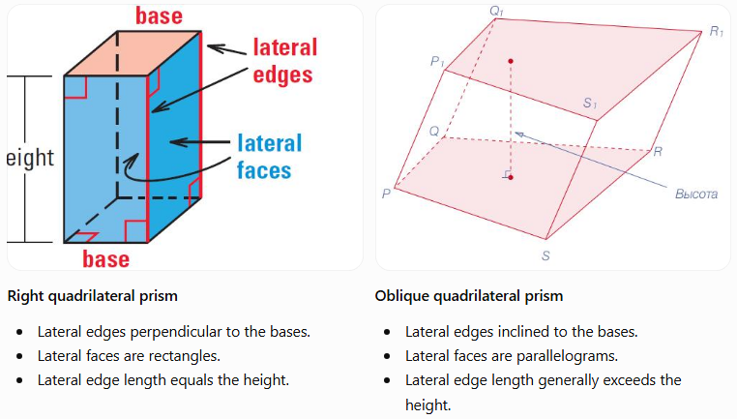
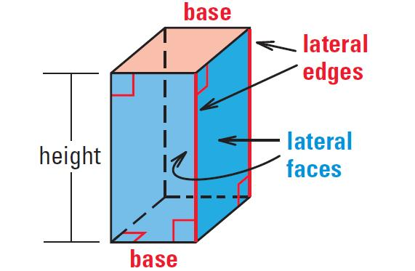
Right quadrilateral prism
- Lateral edges perpendicular to the bases.
- Lateral faces are rectangles.
- Lateral edge length equals the height.
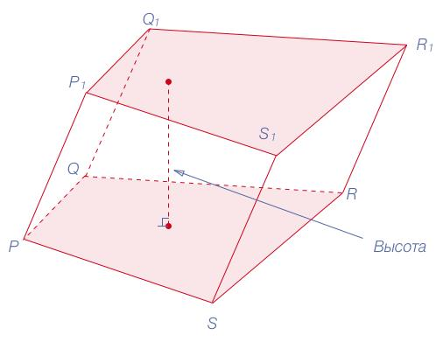
Oblique quadrilateral prism
- Lateral edges inclined to the bases.
- Lateral faces are parallelograms.
- Lateral edge length generally exceeds the height.
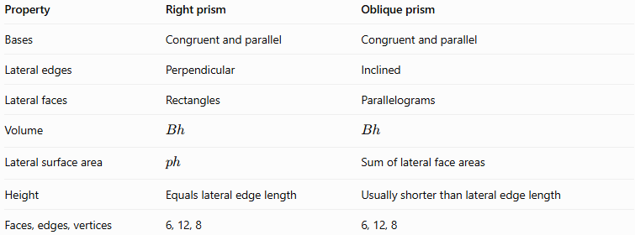
Property | Right prism | Oblique prism
Bases | Congruent and parallel | Congruent and parallel
Lateral edges | Perpendicular | Inclined
Lateral faces | Rectangles | Parallelograms
Volume | $$Bh$$ | $$Bh$$
Lateral surface area | $$ph$$ | Sum of lateral face areas
Height | Equals lateral edge length | Usually shorter than lateral edge length
Faces, edges, vertices | 6, 12, 8 | 6, 12, 8

Applications
# Source: AI Source: Provided by: [Data Path: Persons Table -> ID Column: 1, Name_En Column: Motasem Essam] -> From: [ChatGPT] on [7/25/2026]
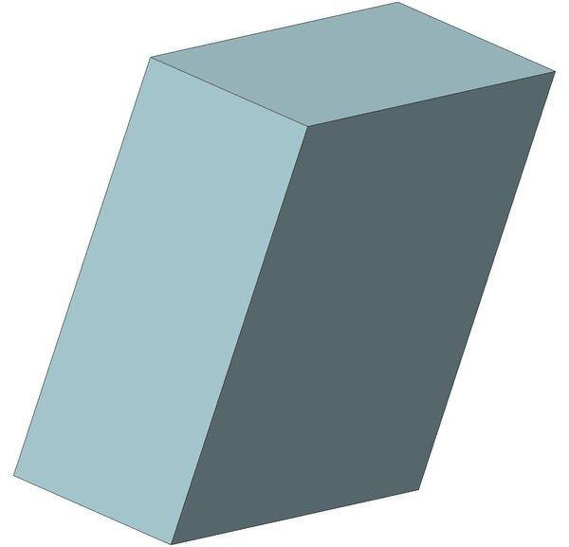
Architecture and construction
Oblique prism geometry can model inclined structural elements, slanted supports, and certain architectural forms.
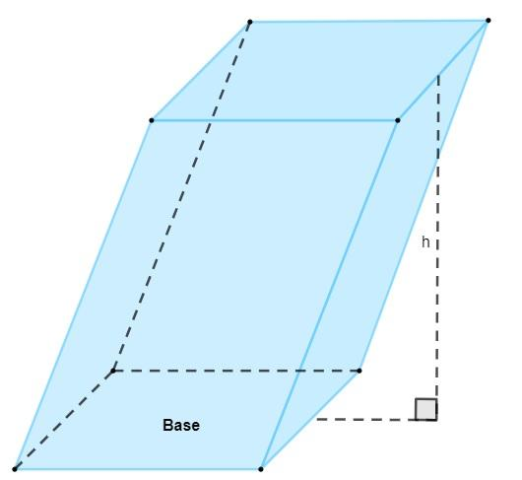
Mathematics education
It demonstrates the difference between perpendicular height and slanted edge length, as well as the properties of parallelograms and prisms.
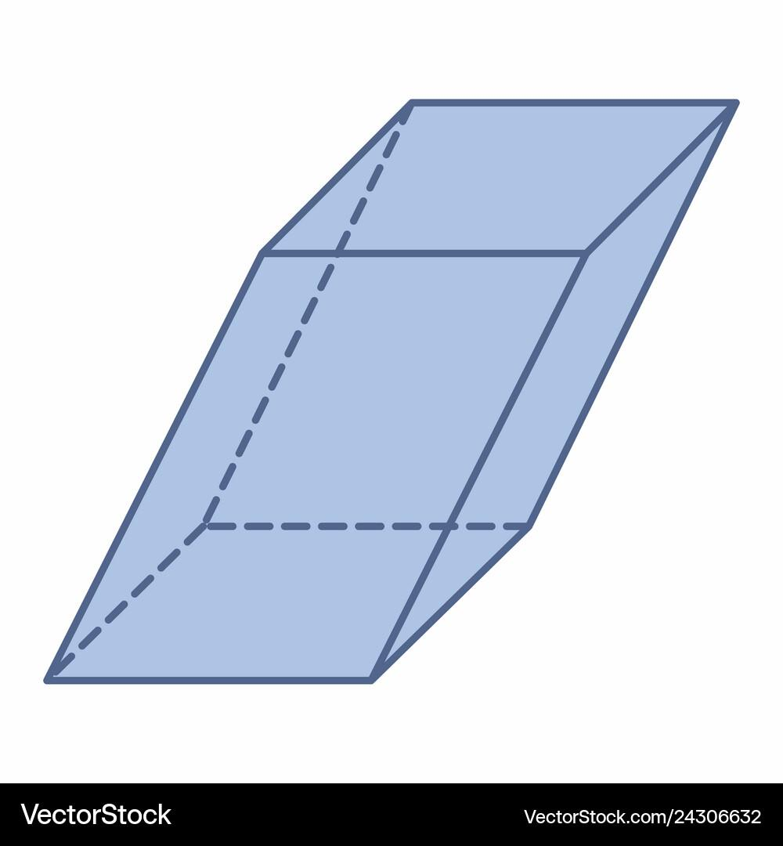
Engineering and 3D modeling
It provides a useful model for studying inclined solids, parallel planes, spatial transformations, and surface calculations.

Key Points
# Source: AI Source: Provided by: [Data Path: Persons Table -> ID Column: 1, Name_En Column: Motasem Essam] -> From: [ChatGPT] on [7/25/2026]
- An oblique quadrilateral prism has two congruent, parallel quadrilateral bases.
- Its lateral edges are inclined to the base planes.
- Its four lateral faces are parallelograms.
- It has 6 faces, 12 edges, and 8 vertices.
- Its volume is $V=Bh$, using the perpendicular height.
- Its lateral surface area is calculated by adding the areas of its four lateral faces.
- Its total surface area is $A_{T}=A_{L}+2B$.
- Unlike a right prism, its lateral edge length is generally not equal to its height.

Conclusion
# Source: AI Source: Provided by: [Data Path: Persons Table -> ID Column: 1, Name_En Column: Motasem Essam] -> From: [ChatGPT] on [7/25/2026]
An oblique quadrilateral prism is distinguished by its inclined lateral edges and parallelogram-shaped lateral faces. Although it leans relative to its base planes, it retains the standard structure of a quadrilateral prism: six faces, twelve edges, and eight vertices. Its volume follows the same formula as that of a right prism, but its lateral surface area requires attention to the individual face altitudes.

